# Week 6 – Assignment 1 – Unix Text Analysis

By: Zach Adair

Regis University

MSDS 650 Data Analytics

## Introduction

For the first assignment of week 6 I will be working with Unix to run a text analysis. Unix is a group of multitasking, multiuser computer operating system which was built to run text-based processes. This first assignment comes in two parts, part one I will need to install either CentOS6, Ubuntu, or Cloudera and then I’ll run through the PDF attachment given for this assignment.

## Assignment I – Part I

From a previous course I already have Cloudera installed on my laptop so I’m going to be using that to complete Assignment 1.

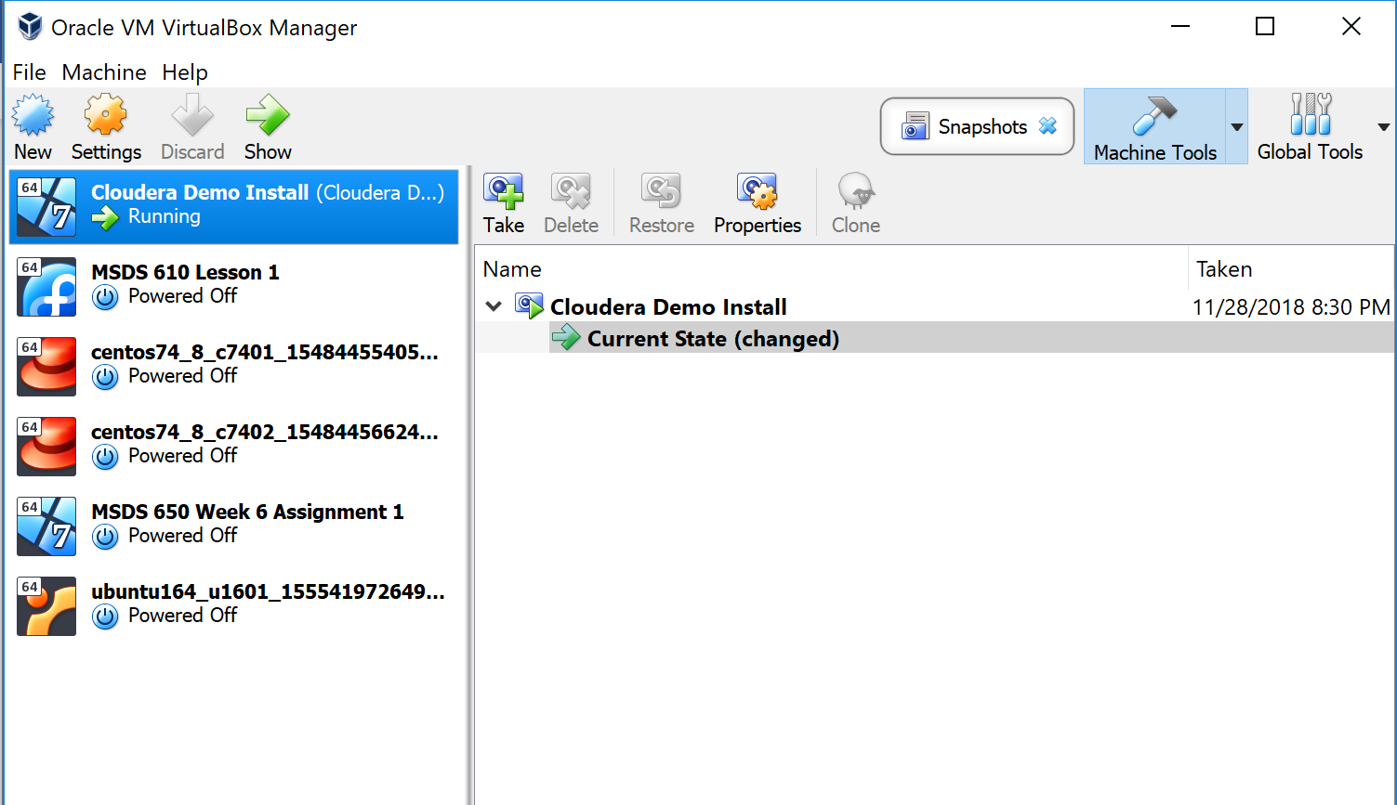

I have my Cloudera machine up and running and now I’m prepared to move onto part two of the assignment.

## Assignment I – Part II

In part two of the assignment I’m going to be working through the tutorial which is working with PDFs using the command tool line and extracting images from PDFs and text files and manipulating them. I’ve never done anything like this before so I’m excited to see the result.

Before I get started on the different command lines to start this assignment there are some things I must first download.

The packages I need to install are:

#yum -y install epel-release

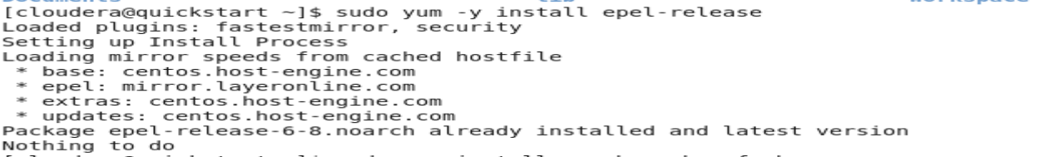

#yum install openbox obconf obmenu

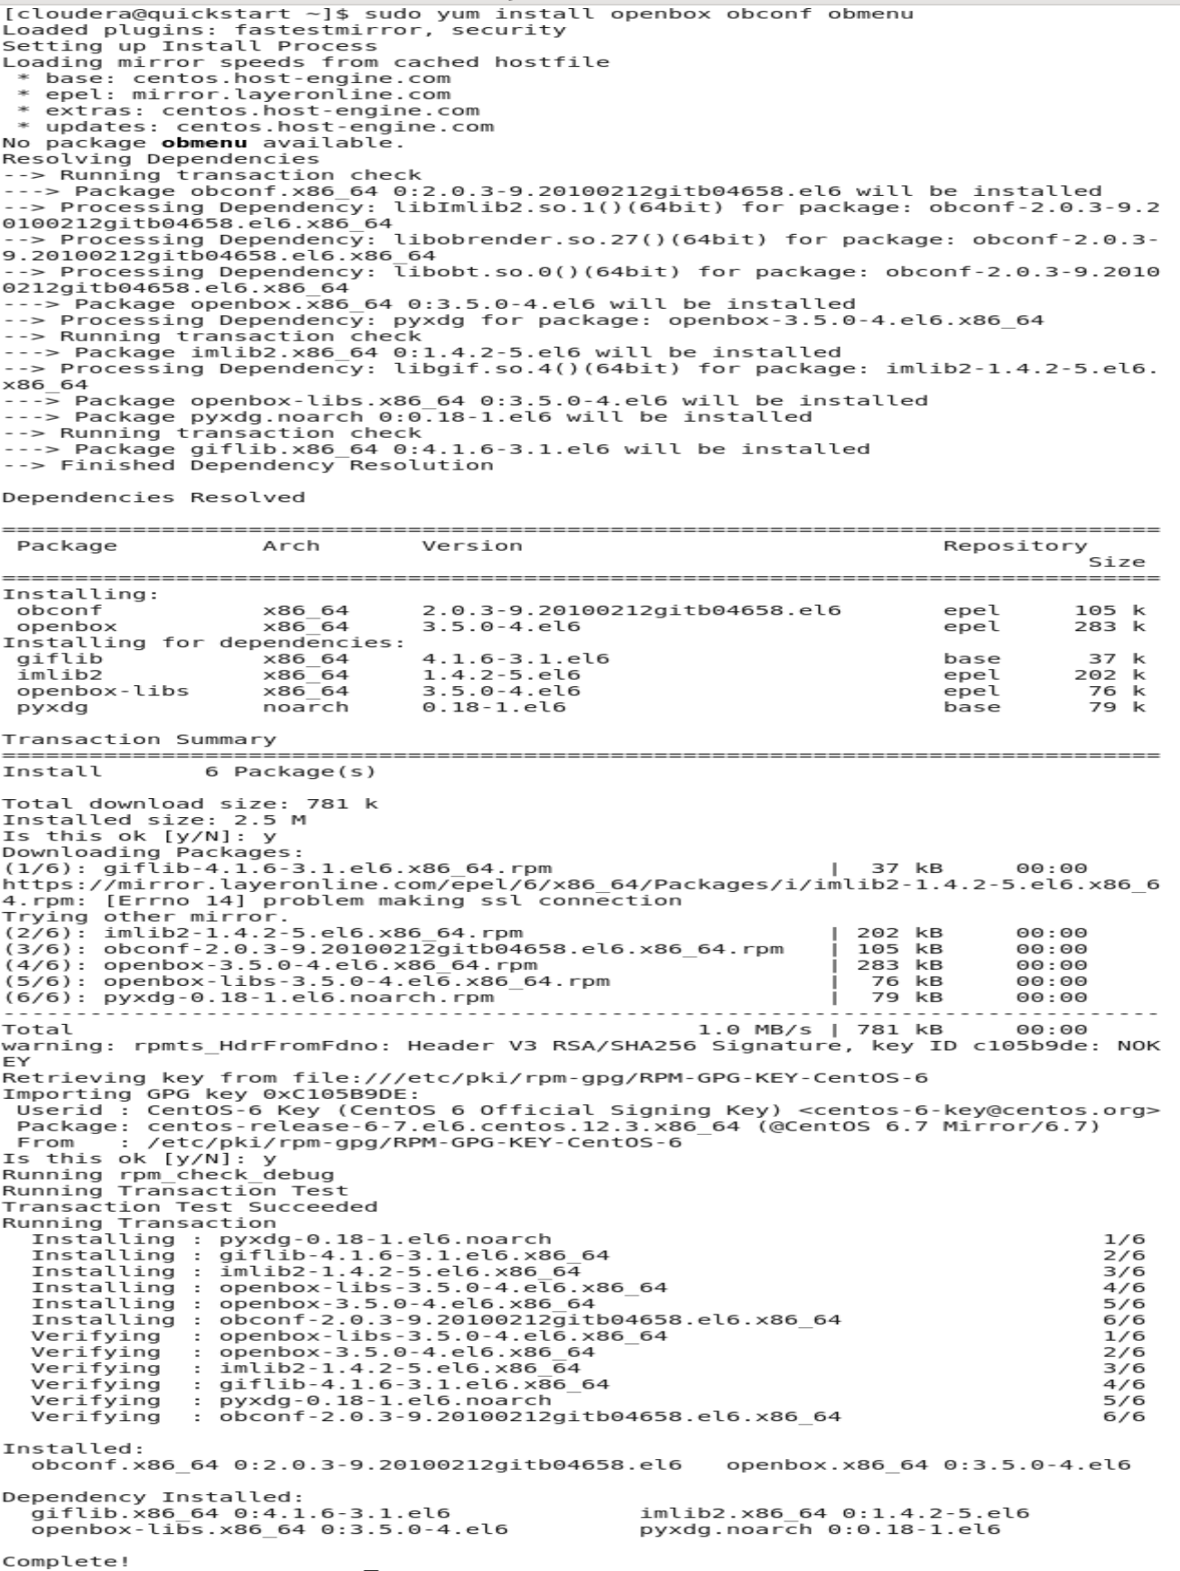

#yum install ImageMagick

#yum install pandoc.x86_64

#yum install tesseract

#yum install xpdf

#wget <https://www.pdflabs.com/tools/pdftk-the-pdf-toolkit/pdftk-2.02-1.e16.x86_64.rpm>

I would show the rest of these installs but they are quite long and don’t fit in one screen capture. After the list given for installation though I can move on to the tutorial and go through the steps provided there.

### Installation

After all the installation I seemingly did to get to this point the installation party still isn’t complete, I have to install the tools for working with Adobe Acrobat PDF documents.

Start with the command: man xpdf

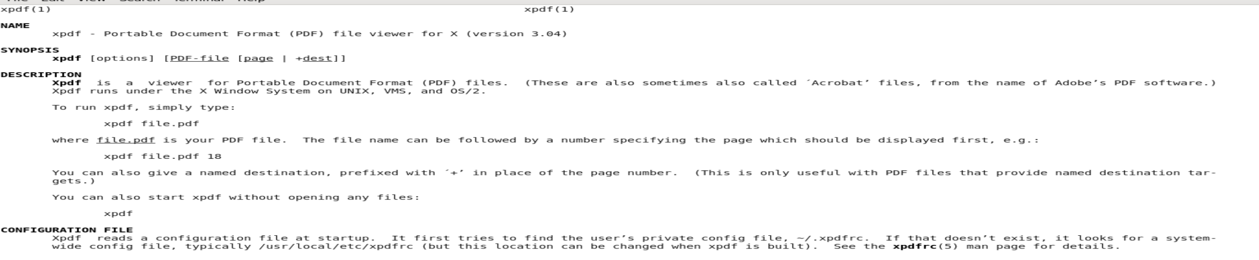

The command opened up a prompt with a fairly detailed description with an introduction, description, configuration and even the proper commands of it listed as well.

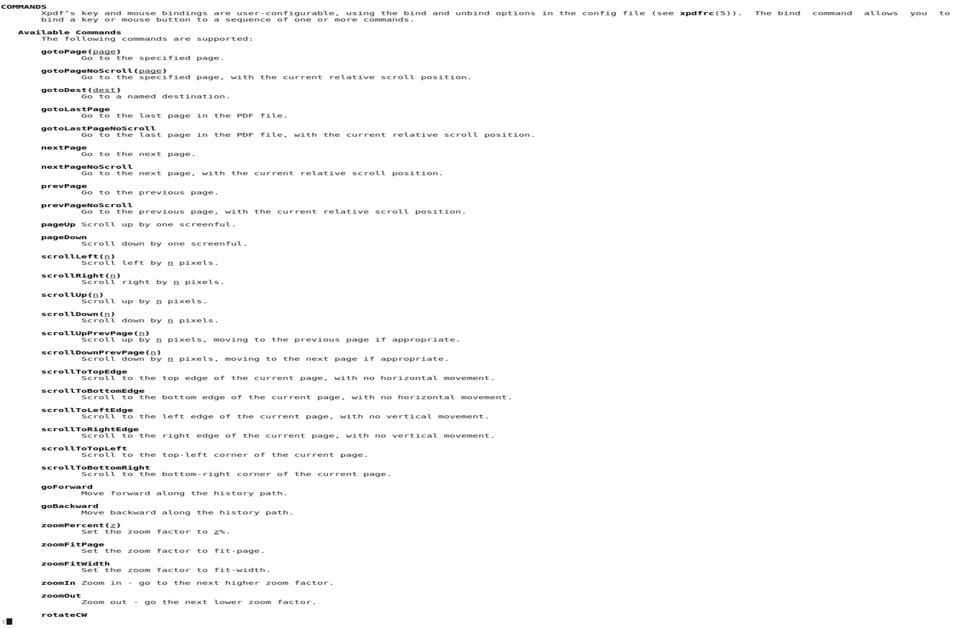

Next I tried the same thing for the commands man pdftk and man pdftotext and though I got no result from the command man pdftk I did for man pdftotext:

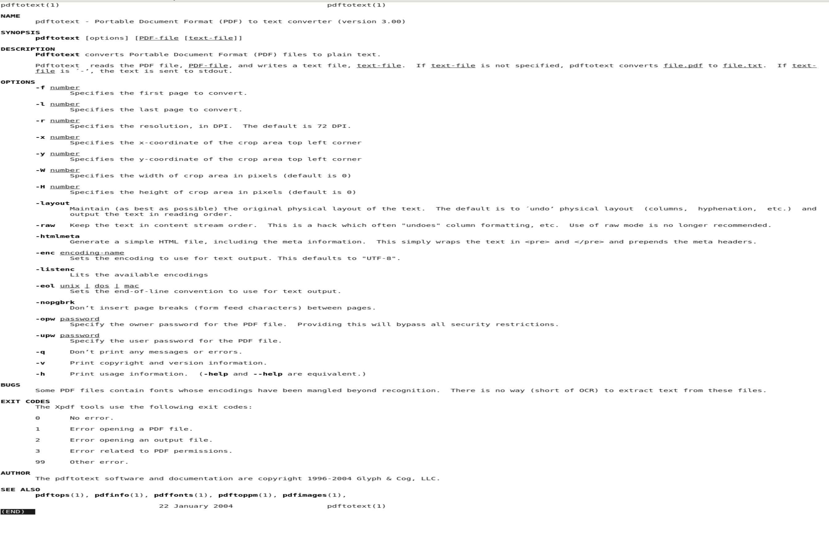

It again gave me a manual of the command and the different components of pdftotext.

Since I didn’t get a manual for pdftk I need to install it. I used the command sudo aptitude install pdftk:

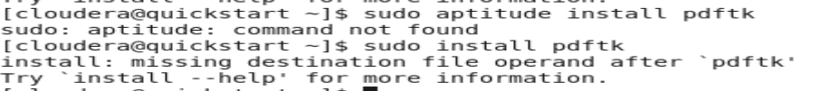

As you can see I ran into an issue, apparently aptitude is not a command so I tried to install it without the aptitude command. I decided I’d try one more way and that is with the same yum command I used earlier to install that list of packages given out. This is my result:

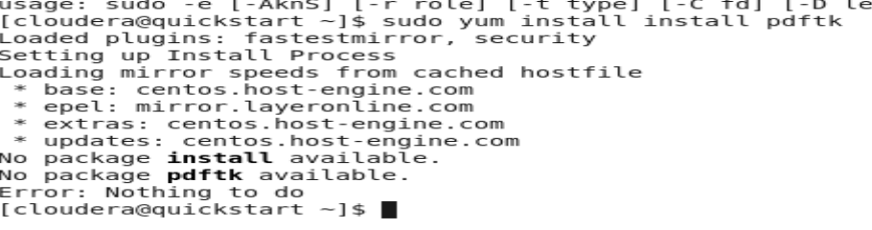

My command seemed to work, the only problem is the pdftk package is non-existent so from here I will just move on and hope it doesn’t cause any issues down the line.

### Viewing PDFs

Start by downloading a PDF that can be worked on. The PDF supplied is from 1923 and it is a book about the wildflowers of Kashmir.

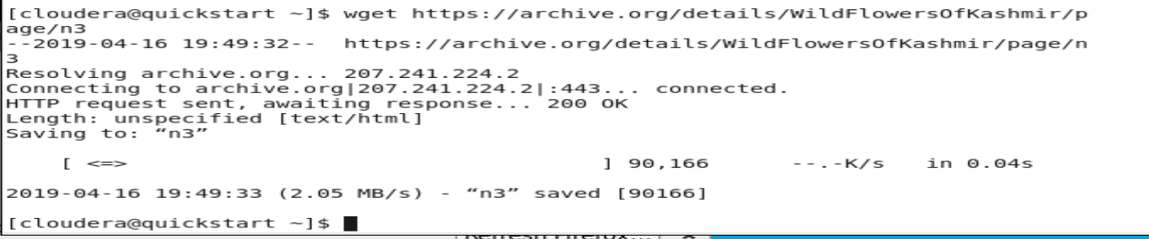

### Extracting Text

Now that the document has be grabbed its time to extract the text from a PDF and taken into a text file.

After having to configure a way for the commands to read my KashmirWidlFlowers.pdf file I finally got something to work. Also after using the less command I was able to see what the file looks like.



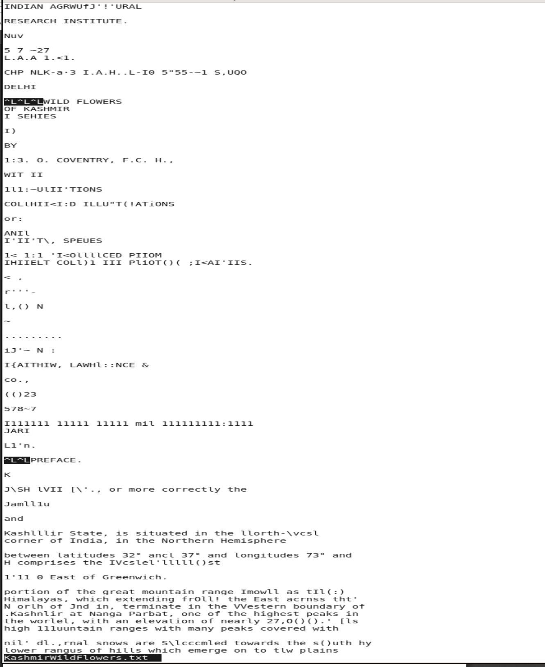

The beginning of the file looks messy but that’s ok after the portion you see above it’s actually quite readable. From here I’m going to use the egrep command:

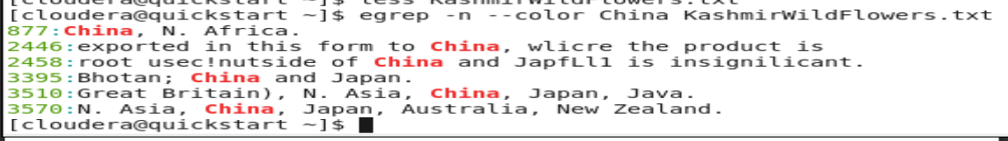

The cool thing that the egrep command does is it will search for whatever word you ask it to and color the word as well to make it easier to spot.

### Extracting page images and creating a contact sheet

During this section is where we will start extracting images from the Kashmir Wild Flowers PDF. I will start by creating a directory and then populating that directory with pictures.

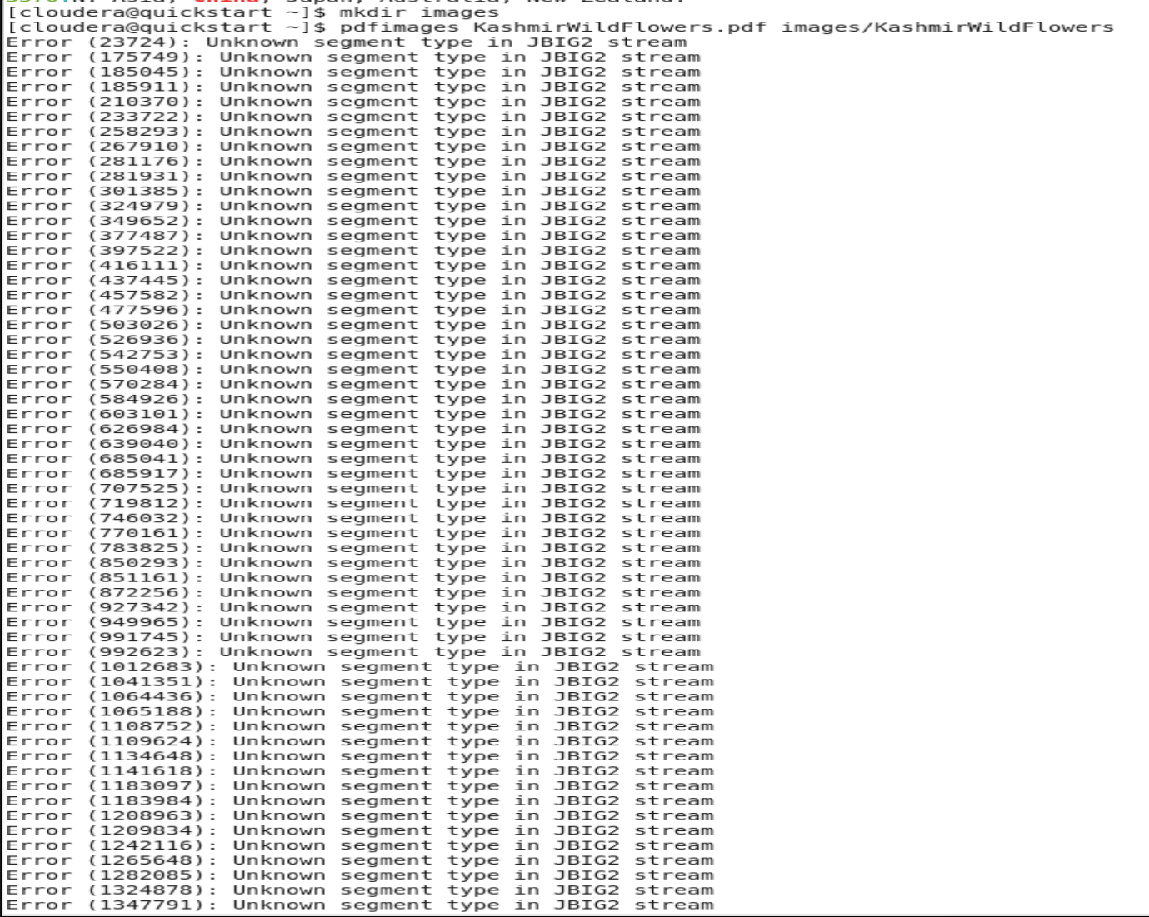

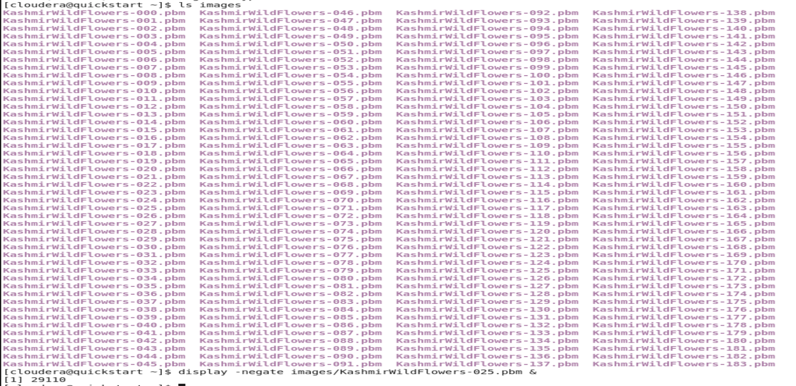

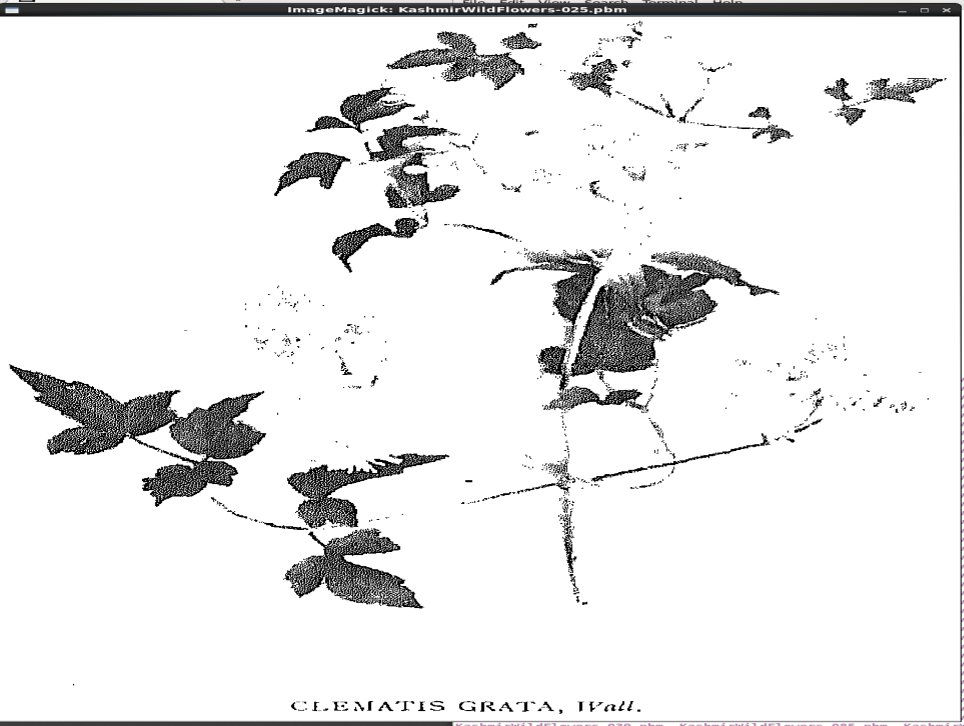

Seeing the picture pop up that it grabbed from the last command was really cool to see. Being able to grab pictures off the PDF like that was something I’ve never done before so that was fun to do.



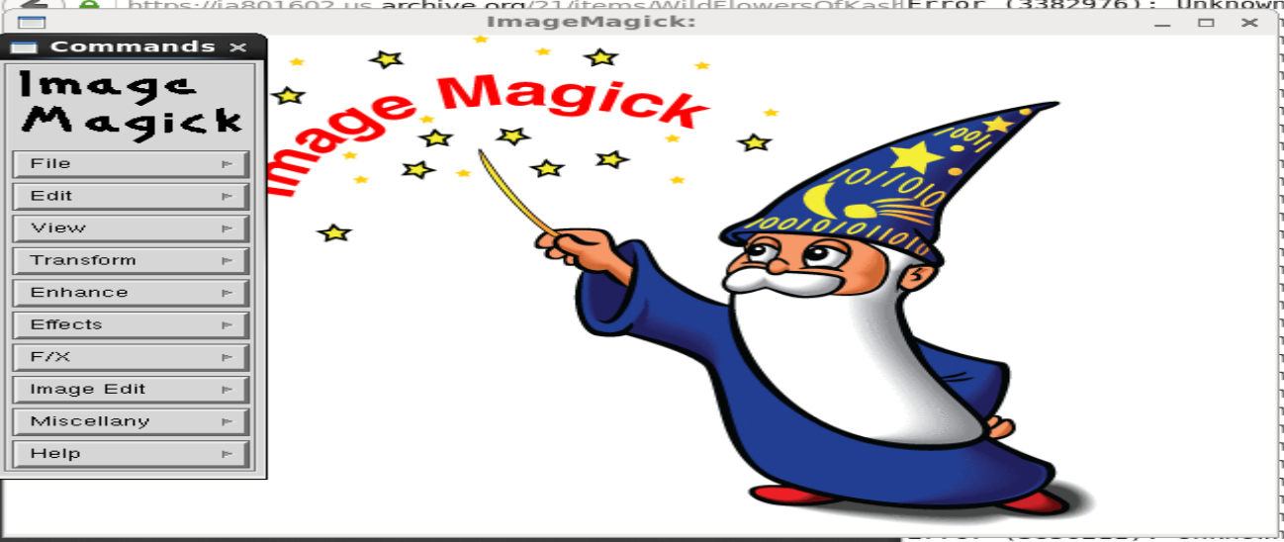

From what we did above we were able to use Image Magick, one of the packages we downloaded earlier, to create the prompt that you see in the bottom image. Listing out all the file names as well as giving us a wizard graphic. The prompt on the left side is interactive and allows users to go in and check out the different files available.

### Iterating through an array

Next we will be taking a copy of each of the flower pages in the first 100 pages and putting them into a new directory.

Starting with storing the file numbers:



The next step is to loop through each element of the array and create a full filename from it. This will be tested before the command is used, so here we echo each filename to the terminal.

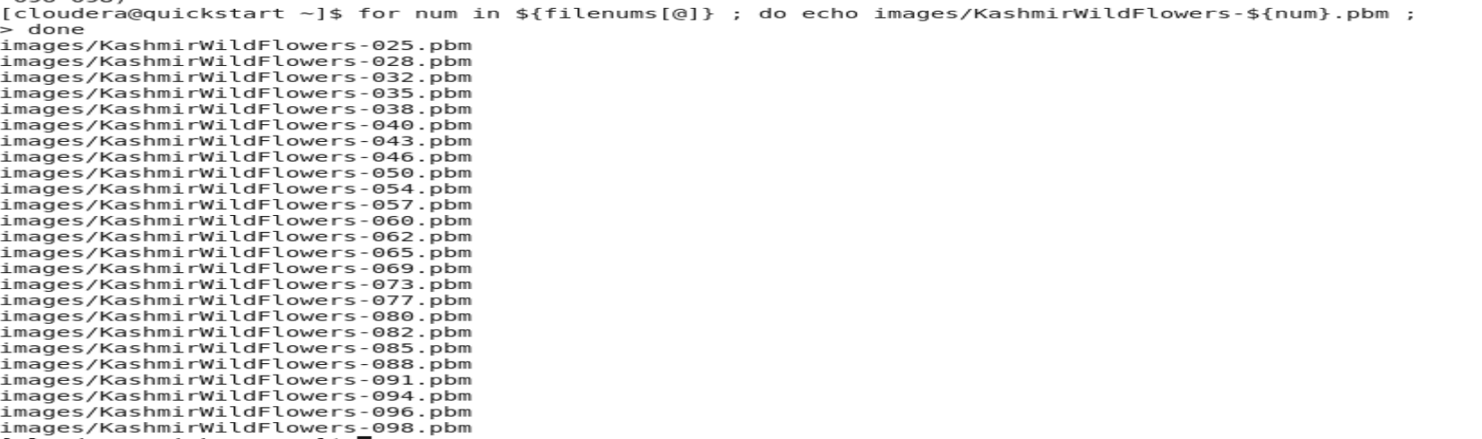

This looks good, we have listed out all of our images that we are meaning to grab.

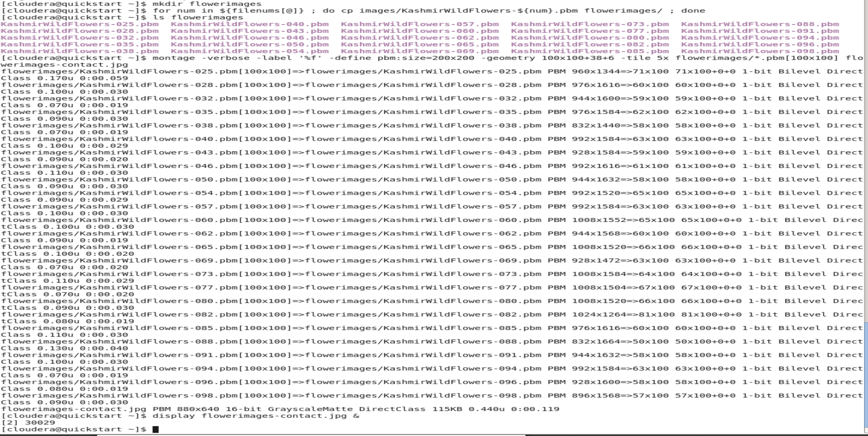

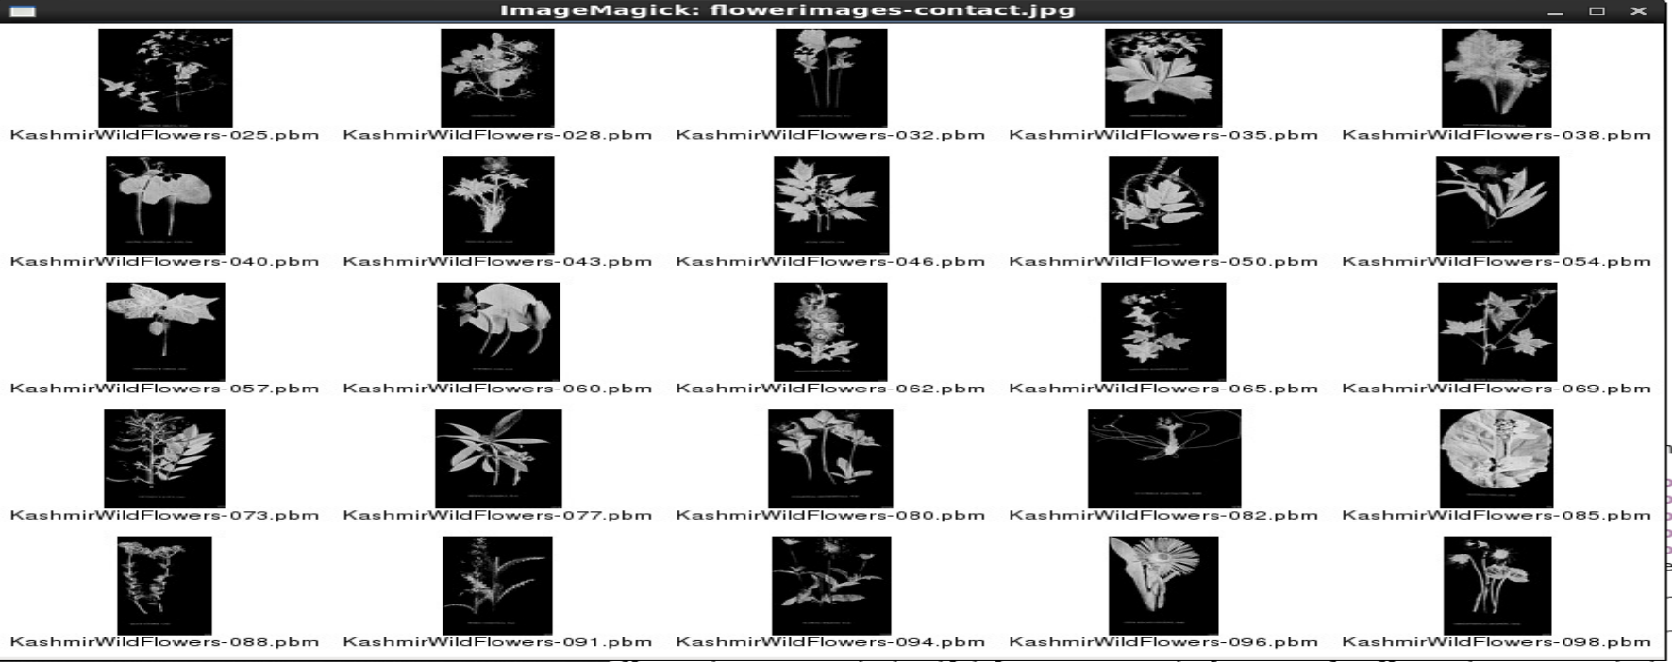

This is the list of images of the flowers from the first 100 pages of the PDF.

### Compiling individual image files into a new PDF

If we have a collection of images files in a directory, we can compile them into a new PDF using Image Magick as well.



### Manipulating PDFs with pdftk

If we remember back to the beginning the pdftk command will not be available because while downloading packages for this assignment it was stated that pdftk did not exist.

But after looking at what a couple of my fellow classmates found I was able to download pdftk into my virtual machine.

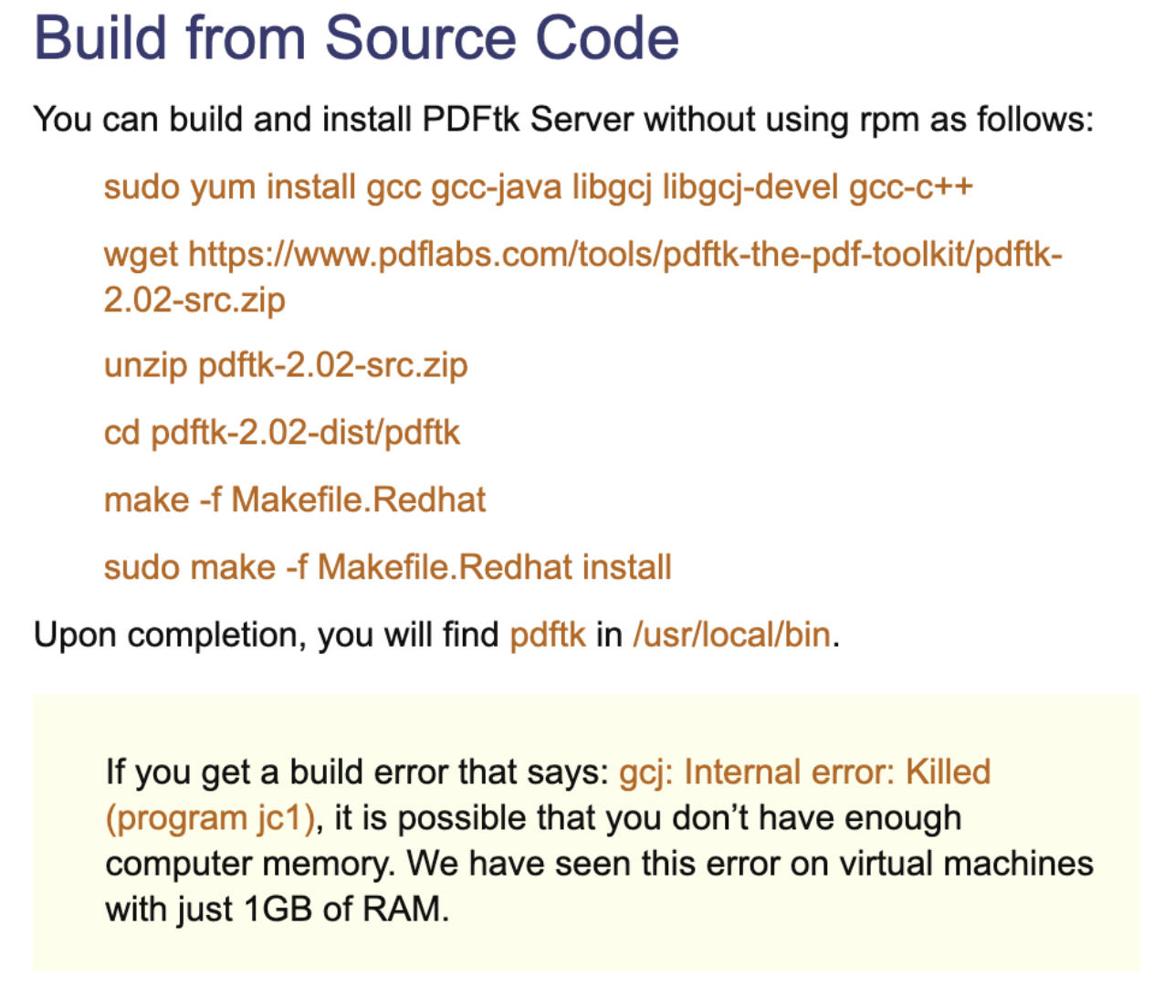

At the end the pdftk file should be in the /usr/local/bin directory:



After finally setting up my pdftk I can move on to manipulating the PDF with pdftk.



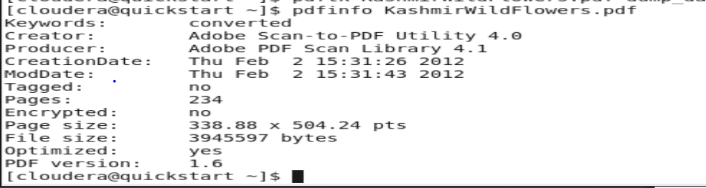

At the end here we are able to look at some of the information provided about the Kashmir Wild Flowers PDF.

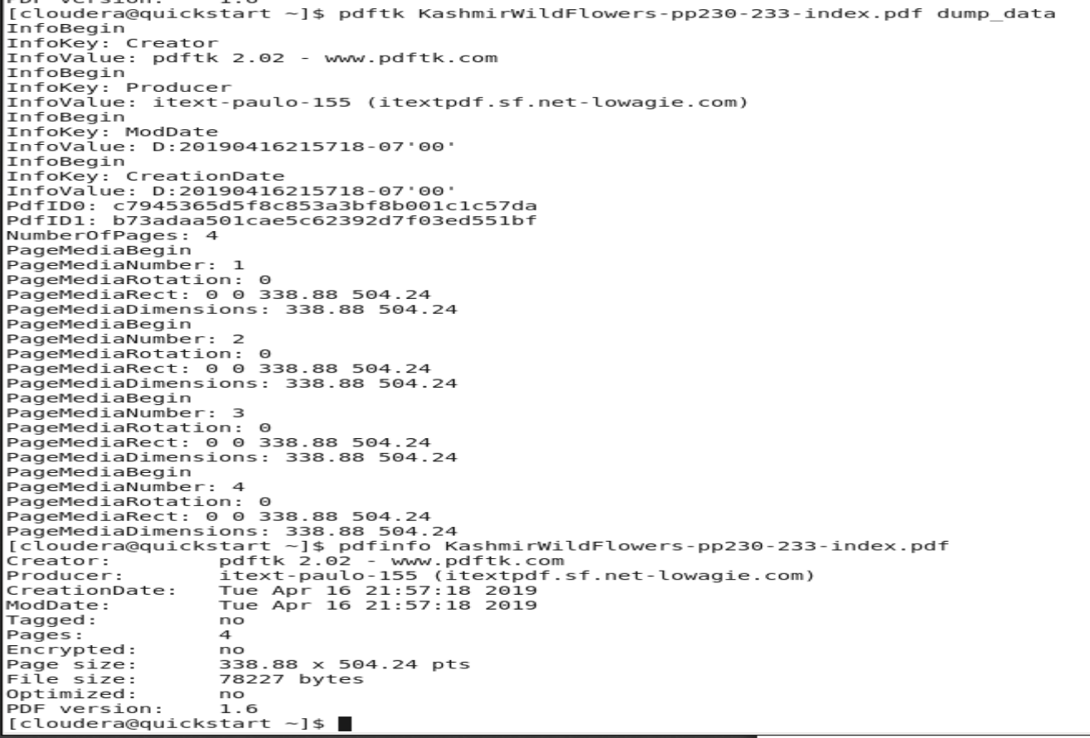

From the commands above were able to get dump the data from pages 230 – 233 and also pull some information about them.

### Bursting a PDF

In this section the pdftk command allows to burst a PDF into single pages, and at the same time outputs file metadata to a file called doc_data.txt.



Now I’ll check my work on page 3.



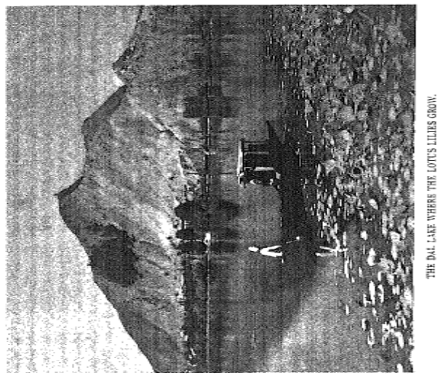



### Adding Metadata

Using pdftk we will add metadata to the PDF to finish the tutorial.

I first must create the KashmirWildFlowers-metadata.txt file and then open it up with a vi command and insert some information.



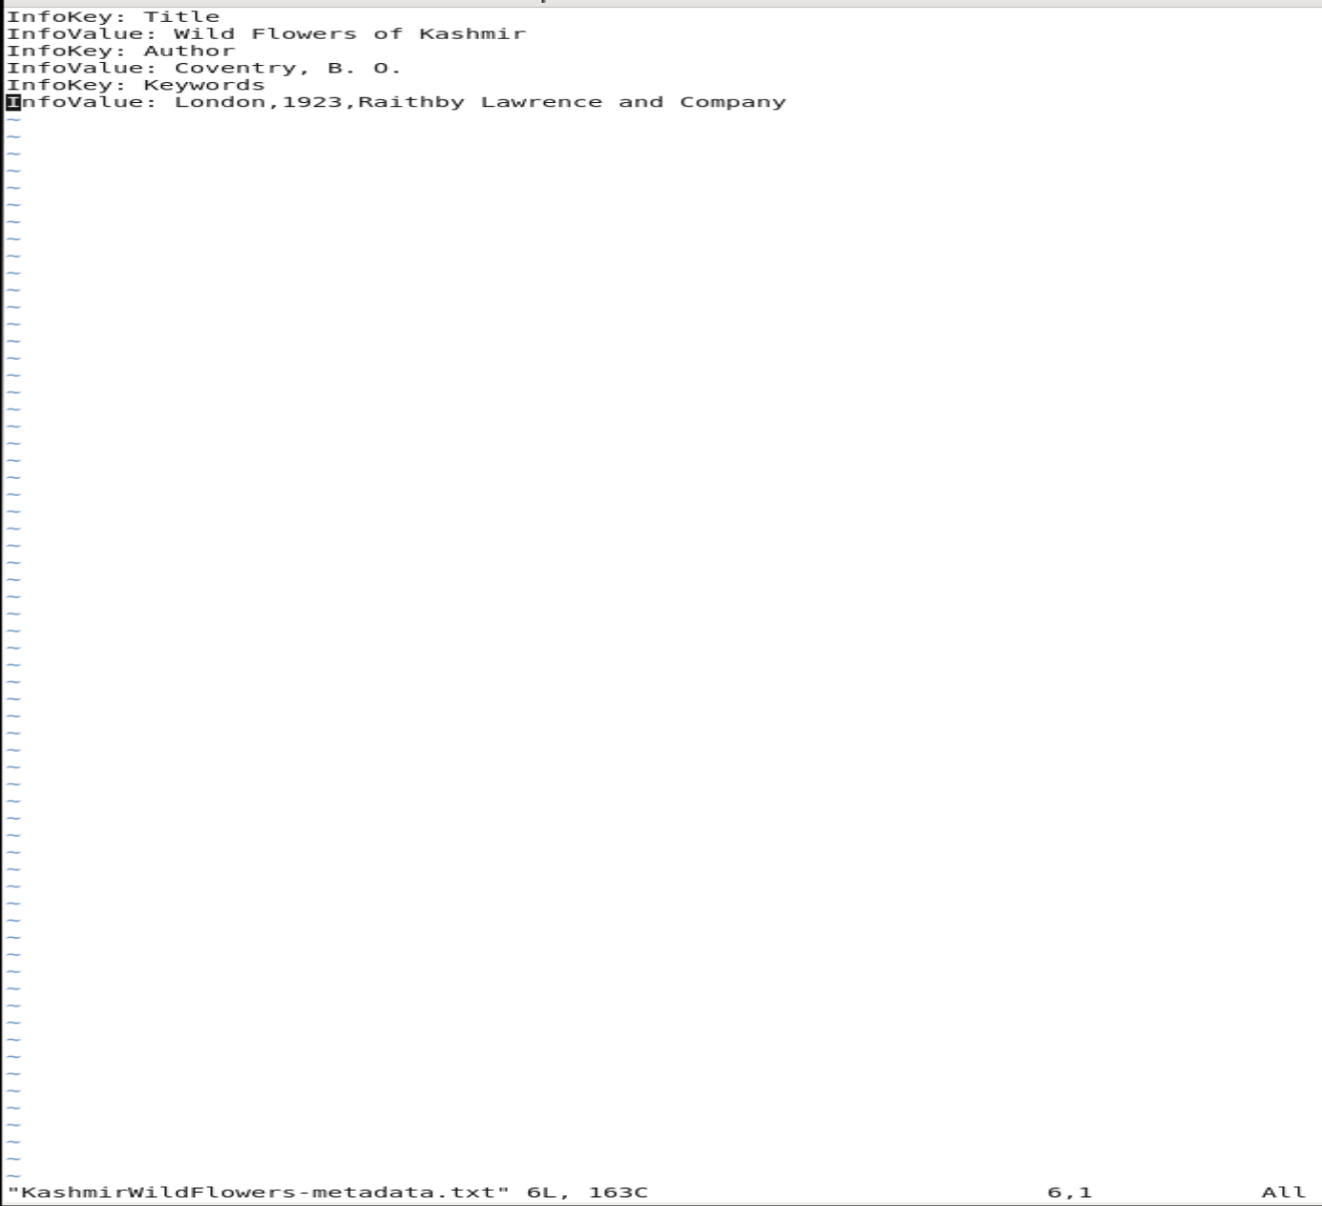

Now that I have made the changes it is time to check my work.

After running the three lines of commands your result should look like this:

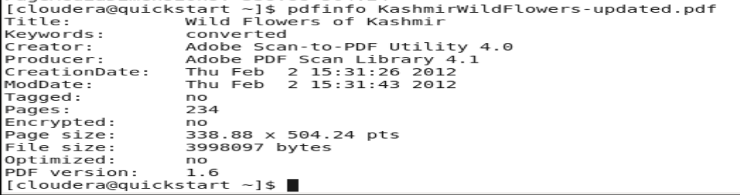

## Summary

For Assignment One of Week 6 I went through a tutorial for Cloudera which pulled pictures from PDFs and manipulated and created different PDFs by creating them and then dumping data from one to another. I found this assignment really interesting because being able to manipulate PDFs, capture pictures from them, and analyze data from it in this way was new for me to see but I think it is great for whenever I would want to use some sort of text analysis I would want to be able to do on a document.